**Arduino Leonardo as ISP**

The Leonardo was my first Arduino, I bought it because it's native USB capabilities (later I found Teensy had the same chip and it was smaller and cheaper, so I order it to make a HID device project I'll post later). After experimenting with Arduino, I decided to migrate from my Arduino Leonardo to a standalone Atmega328p or, for smaller projects, to a microcontroller from the  Attiny family.

After some research I found this guide by [PeterVH](http://petervanhoyweghen.wordpress.com): <http://petervanhoyweghen.wordpress.com/2012/09/16/arduinoisp-on-the-leonardo/>  
 After several failed attempts, I was able to burn the bootloader and upload sketches successfully and wanted to share that with this Instructable.  
  
Disclaimer  
I can not be held responsible for any damages that could occur to you or your equipment while following the procedures present on this page. Also, I give absolutely no warranty on the correctness and usability of the information on this Instructable. Please note, however, that these procedures have worked in my case without any damages or problems.

**Step 1 - Materials.**

- Arduino Leonardo (with usb cable)

- A computer (all steps are based on computer running Windows)

- Wires

- Target Atmel microcontroller

**Step 2: Preparing the Leonardo**

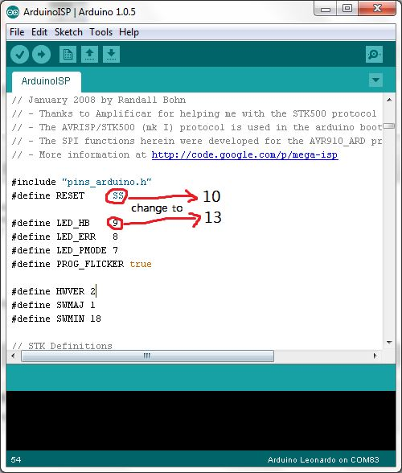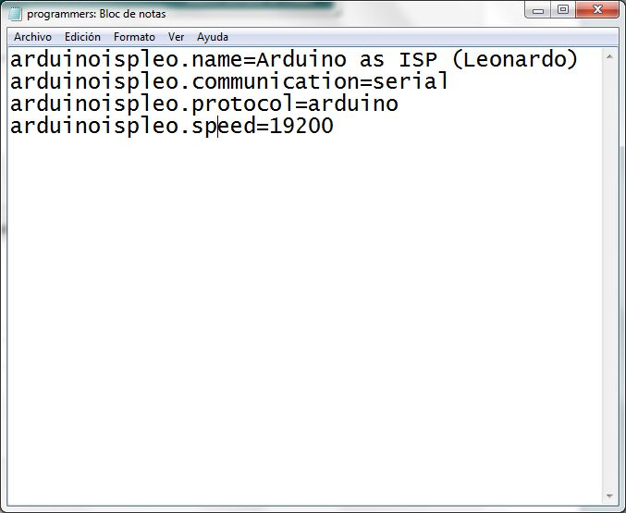

I am assuming that you have already installed and configured the IDE, and you've been able to upload sketches before (If you don't :http://arduino.cc/en/Guide/HomePage).

1- Open Arduino IDE

2- Open the ArduinoISP sketch (File/Examples/ArduinoISP)

3- Change the following lines (see picture 1):

#define RESET SS TO #define RESET 10

#define LED_HB 9 TO #define LED_HB 13

( we want to use digital pin 10 to reset the target and we are setting the heart beating led on pin 13)

4- Save the sketch as LeonardoISP (so you can use it later)

5- We choose Arduino Leonardo (Tools/Boards/Arduino Leonardo) and the appropriate Serial Port (Tools/Serial Port/COM **)

5- Upload

If the sketch was uploaded correctly, you will see the on-board led (the one marked as L) doing a heartbeat sequence.

Now, on your Arduino IDE folder:

1- Create a new folder in "hardware" with the name of leofix

2- Open a text editor and paste this code (picture 2):

arduinoispleo.name=Arduino as ISP (Leonardo)

arduinoispleo.communication=serial

arduinoispleo.protocol=arduino

arduinoispleo.speed=19200

Save the file as programmers.txt (see picture 3)

Next we connect some wires to our Leonardo (picture 4):

Digital Pin 10,1(TX),0(RX)

ICSP MISO,5V,SCK,MOSI,GND (see 6pin pinout on picture 5)

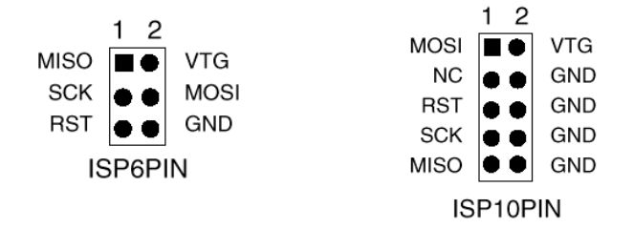

**Step 3: Target Atmel Microcontroller 1: Atmega328p (materials)**

The steps featuring the Atmega328 can be used for Atmega168 and the Atmega8(not tested)

You need this:

(Source: http://arduino.cc/en/Tutorial/ArduinoToBreadboard)

For external 16Mhz crystal configuration:

- Atmega328p----------------------x1

- 10k Ohm resistor (I used 22K)---x1

- 16 MHz clock crystal------------x1

- 22 pF capacitors----------------x2

(or you could just buy any of these kits, like I did:

Virtuabotix Bareduino - Bare minimum 16 MHz Arduino Kit

Virtuabotix Bareduino Plus- Arduino Compatible Microcontroller with Power Regulator

Both are bootloaded as Duemilanove, so you save a step)

For Minimal Circuit (Eliminating the External Clock) configuration:

- Atmega328p---------------------x1

**Step 4: Target Atmel Microcontroller 1: Atmega328p (assemble)**

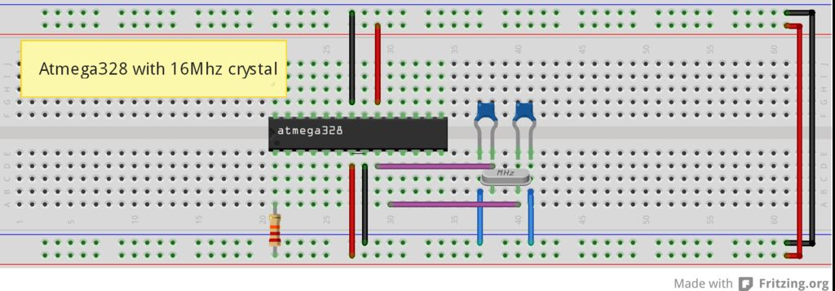

Step 5: Target Atmel Microcontroller 1: Atmega328p (burning bootloader and uploading sketches)

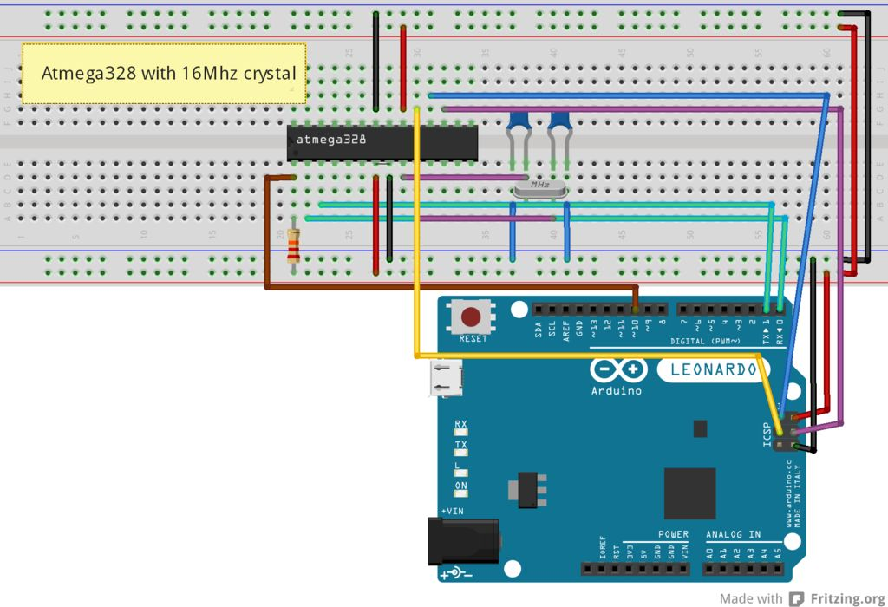

For external 16Mhz crystal and Minimal circuit configuration:

1- Connect the wires from the Leonardo to the atmega328 (please take a look to atmega328 pinouts these are the same with atmega168 -picture 1):

Atmega328 Arduino Leonardo

(in the picture 1 pins on black) (picture 2- 6pin ICSP)

RX pin 2------------------------------------digital pin 0

TX pin 3------------------------------------digital pin 1

MIS pin 18-----------------------------------ICSP pin MISO

MOS pin 17-----------------------------------ICSP pin MOSI

SCK pin 19-----------------------------------ICSP pin SCK

RESET pin1-------------------------------------digital pin 10

And power pins 5v and ground.

Refer to pictures 3 and 4 for the final result

Burning Bootloader (if you bought the Bareduino or you are using a bootloaded Atmega328 skip this step)

*********IMPORTANT: additional step for Minimal circuit configuration*********

1- Go to http://arduino.cc/en/Tutorial/ArduinoToBreadboard and download the Breadboard.zip

2- Create a "hardware" sub-folder in your Arduino sketchbook folder (whose location you can find in the Arduino preferences dialog). If you've previously installed support for additional hardware configuration, you may already have a "hardware" folder in your sketchbook.

3-Move the "breadboard" folder from the zip archive to the "hardware" sub-folder of your Arduino sketchbook.

4-Restart the Arduino software.

5-You should see "ATmega328 on a breadboard (8 MHz internal clock)" in the Tools > Board menu.

******************Additional step finish here******************

1- Check the connections again

2- Select your board:

Atmega328 with external 16mhz crystal ----> Arduino Duemilanove w/ATmega328

Atmega minimal circuit without external crystal -----> ATmega328 on a breadboard (8 MHz internal clock)

3- The Serial Port should be the same as Arduino Leonardo

4- Select Arduino as ISP (Leonardo) in Programmer

5- Select Burn Bootloader at Tools Menu

6- If you get this message: Done burning bootloader, Success! (see pictures 6 and 8)

If you receive an error message, check your connections one by one and repeat the process.

Upload a sketch

1- Do not move your connections

2- Choose a sketch (look at picture 1, Arduino pin configuration in red)

3- Use Upload using programmer from the File menu, Done! (picture 9-classic blink)

If you receive an error message, check your connections one by one and repeat the process.